Please stand or kneel.
We give thanks to you, O God, for the goodness and love which you have made known to us in creation; in the calling of Israel to be your people; in your Word spoken through the prophets; and above all in the Word made flesh, Jesus, your Son. For in these last days you sent him to be incarnate from the Virgin Mary, to be the Savior and Redeemer of the world. In him, you have delivered us from evil, and made us worthy to stand before you. In him, you have brought us out of error into truth, out of sin into righteousness, out of death into life. On the night before he died for us, our Lord Jesus Christ took bread; and when he had given thanks to you, he broke it, and gave it to his disciples, and said, “Take, eat: This is my Body, which is given for you. Do this for the remembrance of me.”
After supper he took the cup of wine; and when he had given thanks, he gave it to them, and said, “Drink this, all of you: This is my Blood of the new Covenant, which is shed for you and for many for the forgiveness of sins. Whenever you drink it, do this for the remembrance of me.” Therefore, according to his command, O Father,
We remember his death
We proclaim his resurrection
We await his coming in glory;
And we offer our sacrifice of praise and thanksgiving to you, O Lord of all; presenting to you, from your creation, this bread and this wine. We pray you, gracious God, to send your Holy Spirit upon these gifts that they may be the Sacrament of the Body of Christ and his Blood of the new Covenant. Unite us to your Son in his sacrifice, that we may be acceptable through him, being sanctified by the Holy Spirit. In the fullness of time, put all things in subjection under your Christ, and bring us to that heavenly country where, with the blessed Virgin Mary and all your saints, we may enter the everlasting heritage of your sons and daughters; through Jesus Christ our Lord, the firstborn of all creation, the head of the Church, and the author of our salvation. By him, and with him, and in him, in the unity of the Holy Spirit all honor and glory is yours, Almighty Father, now and for ever. Amen.
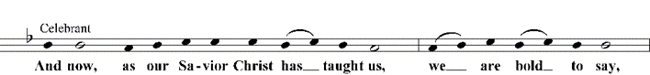

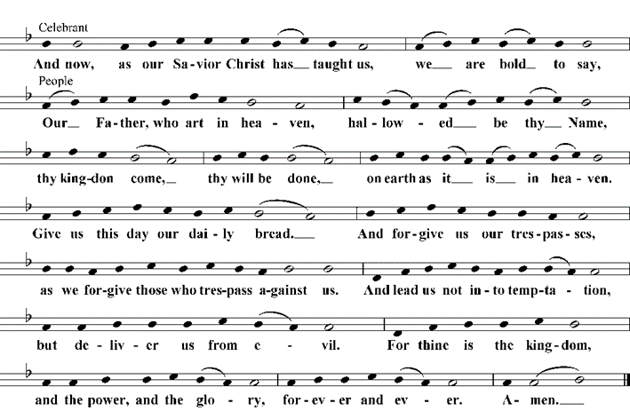

The celebrant breaks the host.
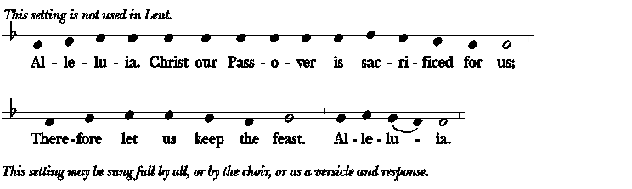

The Gifts of God for the People of God. Take them in remembrance that Christ died for you, and feed on him in your hearts by faith, with thanksgiving.
All baptized Christians, including children, are invited to receive communion. If you wish to receive communion at the altar rail, please come forward at the bidding. Please follow the instructions for receiving communion. If you wish to remain in your pew, communion will be brought to you. Gluten-free wafers are available if you let us know you need one. If you would like to receive a blessing instead of communion, please cross your arms over your chest.
Communion Hymn: “The King of love my shepherd is” Hymnal 645
Post-Communion Prayer (please stand)
Let us pray
Eternal God, heavenly Father, you have graciously accepted us as living members of your Son our Savior Jesus Christ, and you have fed us with spiritual food in the Sacrament of his Body and Blood. Send us now into the world in peace, and grant us strength and courage to love and serve you with gladness and singleness of heart; through Christ our Lord. Amen.
The Blessing
The God of peace, who brought again from the dead our Lord Jesus Christ, the great Shepherd of the sheep, through the blood of the everlasting covenant, make you perfect in every good work to do his will, working in you that which is well-pleasing in his sight; and the blessing of God Almighty, the Father, the Son, and the Holy Spirit, be among you, and remain with you always. Amen.
Closing Hymn: “My faith looks up to thee” Hymnal 691
The Dismissal
Let us go forth in the name of the risen Christ. Alleluia, Alleluia. Thanks be to God. Alleluia, Alleluia!
Organ Postlude: Fugue in D minor BWV 539 J.S. Bach

You are invited to remain quiet for the Postlude or to move to Kelly Hall for further fellowship and refreshments.
Trinity on the Hill Episcopal Church
Los Alamos, New Mexico

The Fourth Sunday of Easter
May 11, 2025, 10:30 am
Holy Eucharist, Rite II
Please allow for quiet prayer before the service begins.
THE ENTRANCE RITE
All hymns will be found in the blue hymnal in your pew rack.
Organ Prelude: Arabesque No. 1 by Claude Debussy arr. M-M. Sauppé
(Please stand as you are able)

Processional Hymn: “Christ the Lord is risen again!” Hymnal 184
Celebrant: Alleluia! Christ is risen! The Lord is risen indeed! Alleluia!
Almighty God, to you all hearts are open, all desires known, and from you no secrets are hid: Cleanse the thoughts of our hearts by the inspiration of your Holy Spirit that we may perfectly love you, and worthily magnify your holy Name; through Christ our Lord. Amen.
The Song of Praise: Glory, to you Lord S 236
Celebrant: The Lord be with you. And also with you. Let us pray.
The Collect of the Day
O God, whose Son Jesus is the good shepherd of your people: Grant that when we hear his voice we may know him who calls us each by name, and follow where he leads; who, with you and the Holy Spirit, lives and reigns, one God, for ever and ever. Amen.
(Please be seated)

The First Lesson: Acts 9:36-43
Now in Joppa there was a disciple whose name was Tabitha, which in Greek is Dorcas. She was devoted to good works and acts of charity. At that time she became ill and died. When they had washed her, they laid her in a room upstairs. Since Lydda was near Joppa, the disciples, who heard that Peter was there, sent two men to him with the request, "Please come to us without delay." So Peter got up and went with them; and when he arrived, they took him to the room upstairs. All the widows stood beside him, weeping and showing tunics and other clothing that Dorcas had made while she was with them. Peter put all of them outside, and then he knelt down and prayed. He turned to the body and said, "Tabitha, get up." Then she opened her eyes, and seeing Peter, she sat up. He gave her his hand and helped her up. Then calling the saints and widows, he showed her to be alive. This became known throughout Joppa, and many believed in the Lord. Meanwhile he stayed in Joppa for some time with a certain Simon, a tanner.
The Word of the Lord. Thanks be to God.

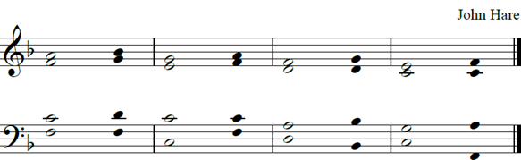

Psalm 23 Dominus regit me
1 The Lord is my | shepherd; *
I shall not be in | want.
2 He makes me lie down in green | pastures *
and leads me beside still | waters.
3 He revives my | soul *
and guides me along right pathways for his | Name’s sake.
4 Though I walk through the valley of the shadow of death,
I shall fear no | evil; *
for you are with me; your rod and your staff, they | comfort me.
5 You spread a table before me in the presence of those who | trouble me; *
you have anointed my head with oil,and my cup is running | over.
6 Surely your goodness and mercy shall follow me all the days of my | life, *
and I will dwell in the house of the Lord for | ever.

The Epistle: Revelation 7:9-17
I looked, and there was a great multitude that no one could count, from every nation, from all tribes and peoples and languages, standing before the throne and before the Lamb, robed in white, with palm branches in their hands. They cried out in a loud voice, saying, “Salvation belongs to our God who is seated on the throne, and to the Lamb!” And all the angels stood around the throne and around the elders and the four living creatures, and they fell on their faces before the throne and worshiped God, singing, “Amen! Blessing and glory and wisdom and thanksgiving and honor and power and might be to our God forever and ever! Amen.”
Then one of the elders addressed me, saying, "Who are these, robed in white, and where have they come from?" I said to him, "Sir, you are the one that knows." Then he said to me, "These are they who have come out of the great ordeal; they have washed their robes and made them white in the blood of the Lamb. For this reason they are before the throne of God, and worship him day and night within his temple, and the one who is seated on the throne will shelter them. They will hunger no more, and thirst no more; the sun will not strike them, nor any scorching heat; for the Lamb at the center of the throne will be their shepherd, and he will guide them to springs of the water of life, and God will wipe away every tear from their eyes."
The Word of the Lord. Thanks be to God.

Sequence Hymn: “Good Christians all, rejoice and sing!” Hymnal 205

The Holy Gospel: John 10:22-30

(Please stand) The Holy Gospel of our Lord Jesus Christ, according to John. Glory to you, Lord Christ.
At that time the festival of the Dedication took place in Jerusalem. It was winter, and Jesus was walking in the temple, in the portico of Solomon. So the Jews gathered around him and said to him, "How long will you keep us in suspense? If you are the Messiah, tell us plainly." Jesus answered, "I have told you, and you do not believe. The works that I do in my Father's name testify to me; but you do not believe, because you do not belong to my sheep. My sheep hear my voice. I know them, and they follow me. I give them eternal life, and they will never perish. No one will snatch them out of my hand. What my Father has given me is greater than all else, and no one can snatch it out of the Father's hand. The Father and I are one."
The Gospel of the Lord. Praise to you, Lord Christ.
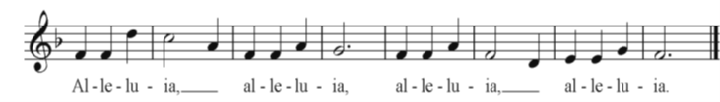

Zimbabwe Alleluia
The Children’s Sermon: The Rev. Mary Ann Hill
The Sermon: The Rev. Mary Ann Hill
The Nicene Creed (Please stand as you are able)
We believe in one God, the Father, the Almighty, maker of heaven and earth, of all that is, seen and unseen. We believe in one Lord, Jesus Christ, the only Son of God, eternally begotten of the Father, God from God, Light from Light, true God from true God, begotten, not made, of one Being with the Father. Through him all things were made. For us and for our salvation he came down from heaven: by the power of the Holy Spirit he became incarnate from the Virgin Mary, and was made man. For our sake he was crucified under Pontius Pilate; he suffered death and was buried. On the third day he rose again in accordance with the Scriptures; he ascended into heaven and is seated at the right hand of the Father. He will come again in glory to judge the living and the dead, and his kingdom will have no end. We believe in the Holy Spirit, the Lord, the giver of life, who proceeds from the Father and the Son. With the Father and the Son he is worshiped and glorified. He has spoken through the Prophets. We believe in one holy catholic and apostolic Church. We acknowledge one baptism for the forgiveness of sins. We look for the resurrection of the dead, and the life of the world to come. Amen.
The Prayers of the People, Form III (Stand or kneel
The Leader and People pray responsively
Father, we pray for your holy Catholic Church; That we all may be one.
Grant that every member of the Church may truly and humbly serve you; That your Name may be glorified by all people.
We pray for all bishops, priests and deacons; That they may be faithful ministers of your Word and Sacraments.
We pray for all who govern and hold authority in the nations of the world; That there may be justice and peace on the earth.
Give us grace to do your will in all that we undertake; That our works may find favor in your sight.
Have compassion on those who suffer from any grief or trouble; That they may be delivered from their distress.
Give to the departed eternal rest; Let light perpetual shine upon them.
We praise you for your saints who have entered into joy; May we also come to share in your heavenly kingdom.
Let us pray for our own needs and those of others.
Silence
The People may add their own petitions. The Celebrant adds a concluding Collect.
The Peace
Celebrant: The peace of the Lord be always with you. And also with you.
Announcements
Birthday and Anniversary Prayer
O God, our times are in your hand: Look with favor, we pray, on your servant N, as he begins another year. Grant that he may grow in wisdom and grace, and strengthen his trust in your goodness all the days of his life; through Jesus Christ our Lord. Amen.
THE HOLY COMMUNION
Offertory Anthem: “Lead Me, Lord” S.S. Wesley
When the gifts are presented at the altar, the congregation stands.
Celebrant: All things come of thee, O Lord. And of thine own have we given thee.
The Great Thanksgiving: Eucharistic Prayer A
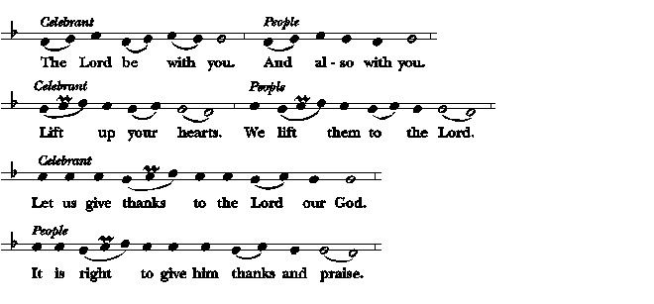
The people remain standing. The Celebrant, whether bishop or priest, faces them and says

It is right, and a good and joyful thing, always and everywhere to give thanks to you, Father Almighty, Creator of heaven and earth. But chiefly are we bound to praise you for the glorious resurrection of your Son Jesus Christ our Lord; for he is the true Paschal Lamb, who was sacrificed for us, and has taken away the sin of the world. By his death he has destroyed death, and by his rising to life again he has won for us everlasting life. Therefore we praise you, joining our voices with Angels and Archangels and with all the company of heaven, who for ever sing this hymn to proclaim the glory of your Name:
